There are several ways to provide continuity in your scrap quilts while at the same time giving the eyes a resting place and allowing enjoyment of a wide variety of prints and patterns.

- USE NEUTRAL BACKGROUNDS TO COMBINE A VARIETY OF SCRAPS.

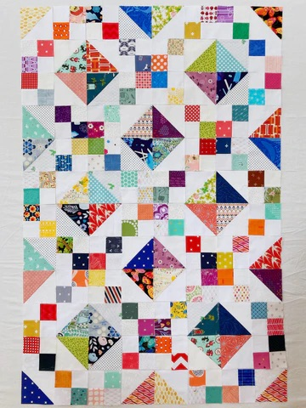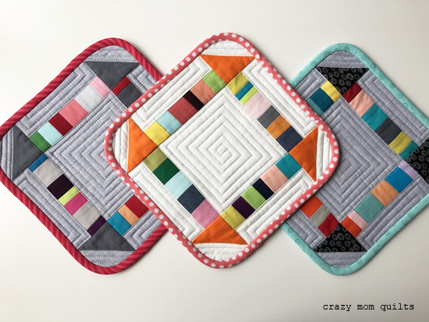
When you use a wide variety of fabrics scraps with lots of color, a neutral cream solid or tone on tone for the background creates a sense of unity in the quilt.

USE A SINGLE SASHING FABRIC AND SINGLE CONTRAST POST FABRIC TO UNIFY YOUR QUILT.
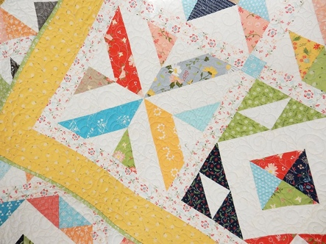
Another method used to unify the colorful scrappy quilts is to use the same sashing throughout and use a contrast post fabric throughout.

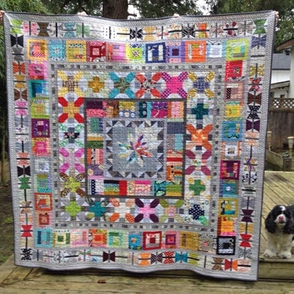
TRY A MEDALLION STYLE SCRAP QUILT.

Making a medallion quilt can be a great way for beginner scrap quilters to achieve a look they love. Because each section of the quilt is completed from the inside out, you can make sure you are happy with the mix of fabrics each step of the way. If a border doesn’t work, it can be easily changed before the next “layer” is added.

4. UNIFY BY INCLUDING ONE COLOR IN EACH BLOCK.
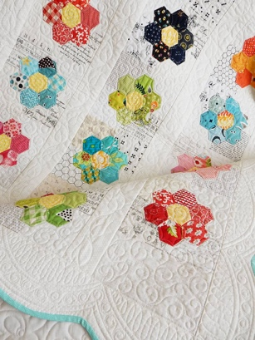
In this quilt Flower Garden, the quilt is unified by using a yellow center for each flower. While the shades of yellow varied, this continuity helped to unite the various blocks in the quilt.

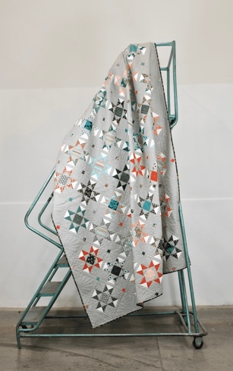
5. UNIFY WITH A SMALL-SCALE MEDIUM OR DARK BACKGROUND.

Use a medium grey small scale polka dot as a background in order to unify a scrappy quilt. Also used a bit of white or one color in each of the blocks to make the blocks stand out. While the sashing posts are scrappy, the background print does a great job of unifying the quilt as a whole.

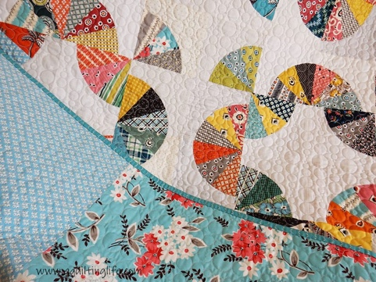
6. USE OPEN SPACE TO UNIFY YOUR QUILT.

The open space in this quilt is used to unify the scraps in this quilt. In this quilt, the string of pearls all-over quilting pattern also kept the quilting from distracting the eyes too much and led to a more cohesive finish.

